Week 8: Database Relationship Analysis using Joins
Scenario:
The e-commerce company stores customer, product, order, and payment information in separate tables. The management team wants to combine these related tables to understand customer purchases, order details, and payment status.

Implement INNER JOIN Concept:
INNER JOIN returns only matching records from both tables.

Tasks:
- Display customer details along with their orders.
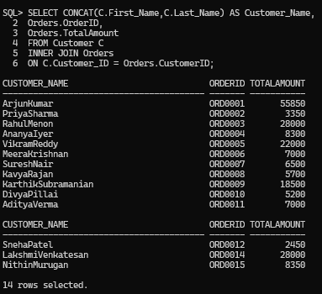
- Display order details with payment information.

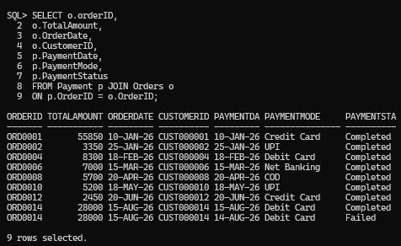
- Retrieve products purchased by customers.

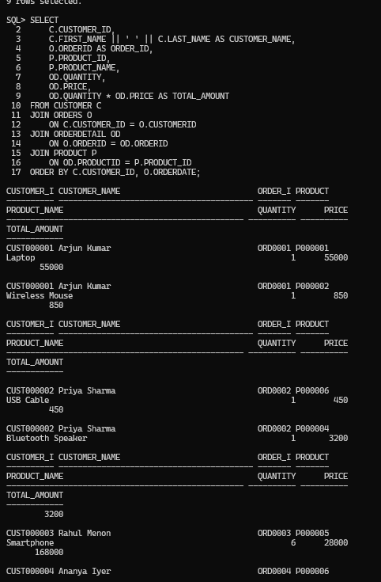

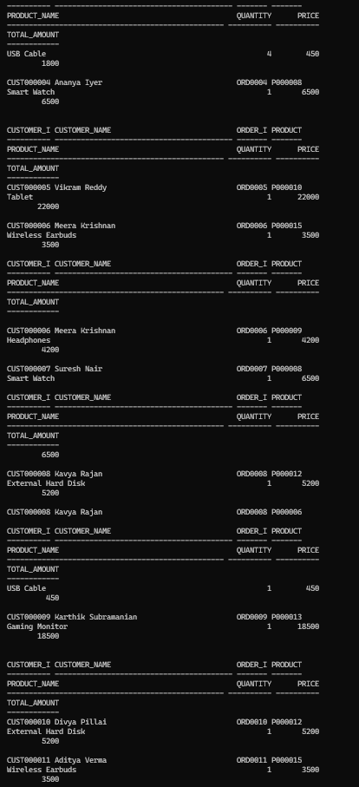

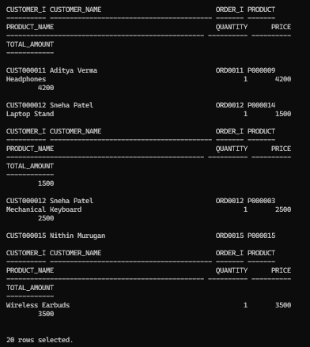

Implement LEFT JOIN Tasks:
- Display all customers including customers who have not placed orders.

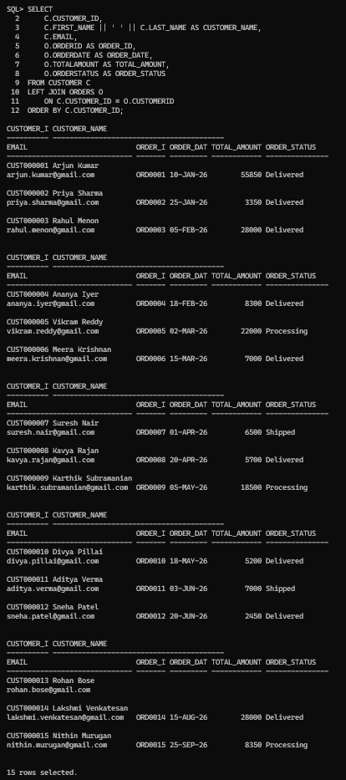

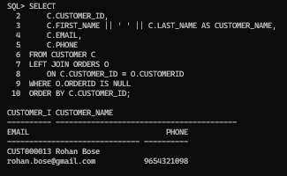
- Find customers without any purchases.
- Display all products including products with no sales.
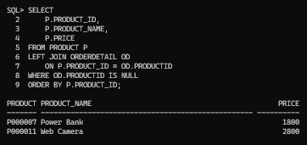

Implement RIGHT JOIN Concept:
RIGHT JOIN returns all records from the right table and matching records from the left table.

Tasks:
- Display all orders with customer information.

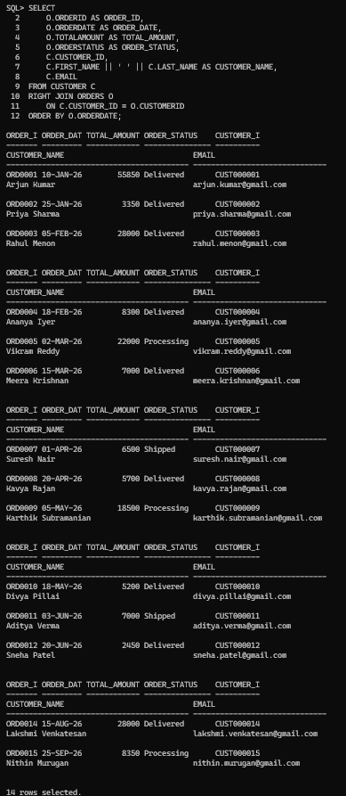
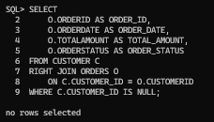
- Find orders where customer details are missing.

- Display all payment records with order details.
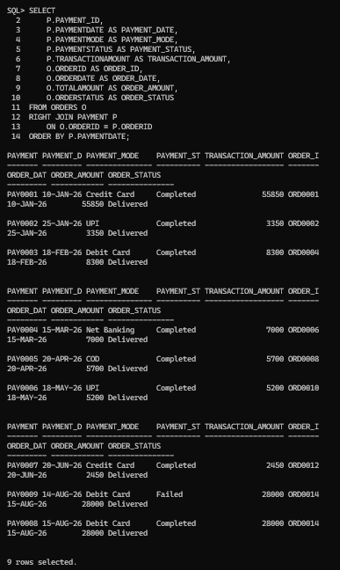

Retrieve Complete Order Details Task:
Generate a complete order report by combining:
  - Customer Name
  - Product Name
  - Quantity
  - Order Date
  - Total Amount
  - Payment Status

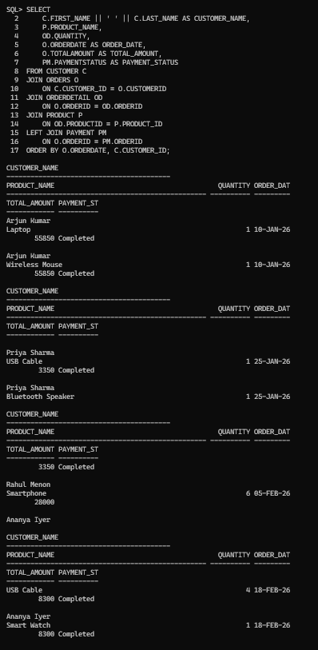

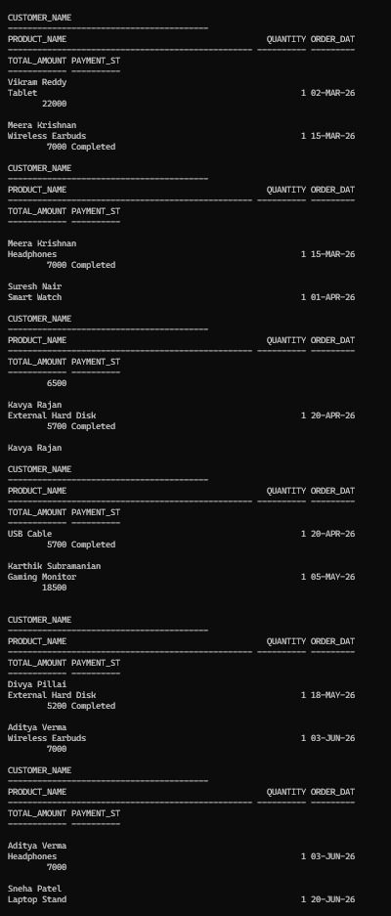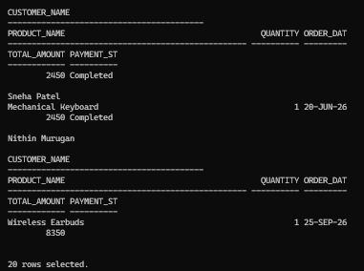

Display Customer Purchase History Tasks:
Write queries to find:
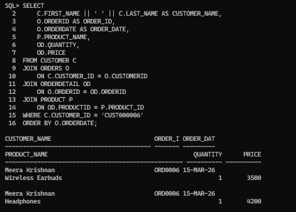
- All products purchased by a customer.
- Total amount spent by each customer.
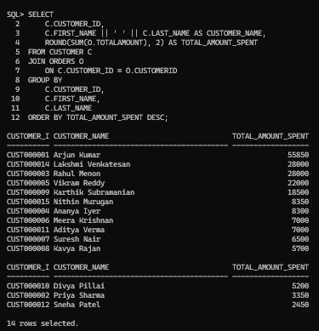

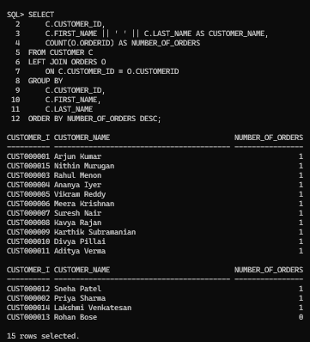
- Number of orders placed by each customer.
- Latest purchase details of customers.

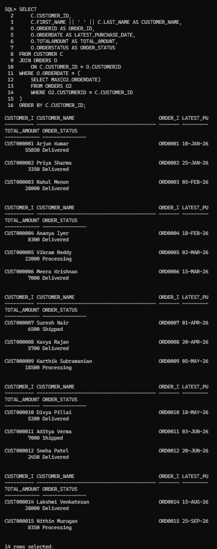

Generate Multi-Table Business Reports Report 1: Customer Order Report
Display:
  - Customer name
  - Order ID
  - Order date
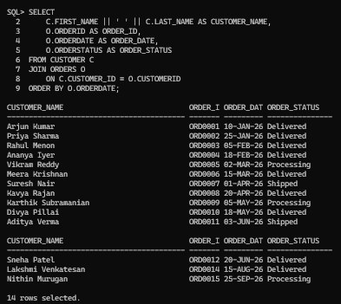
  - Order status

Report 2: Sales Report
Display:
  - Product name
  - Quantity sold
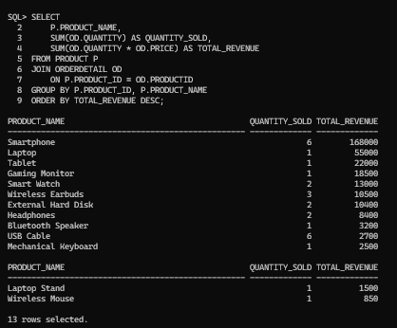
  - Total revenue

Report 3: Payment Analysis Report
Display:
  - Payment mode
  - Number of transactions
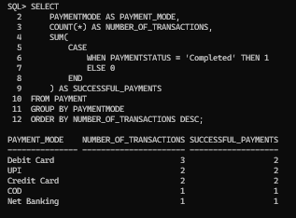
  - Successful payments

Report 4: Customer Purchase Analysis
Find:
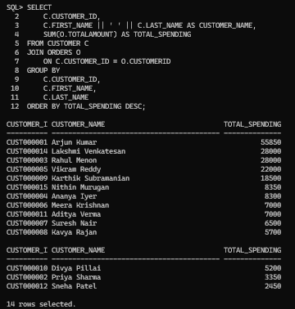
  - Top purchasing customers
  - Customers with maximum orders

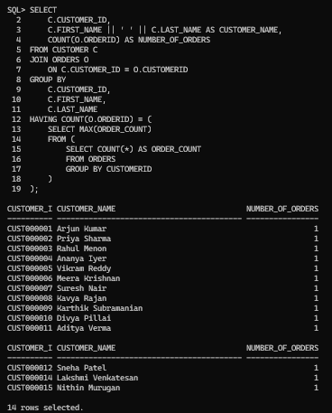
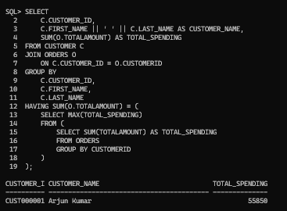
  - Customers with highest spending

